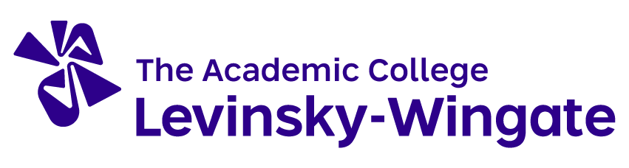
The Wingate Institute, Netanya 4290200, Israel
Phone: +972-9-8639222 Fax: +972-9-8639377 E-mail: wincol@wincol.ac.il Website: http://en.wincol.ac.il/

APPLICATION FORM FOR INTERNATIONAL STUDENTS
(Complete the form clearly in CAPITAL letters)

ACADEMIC YEAR: 2022__ - 2023__

PERSONAL DATA
Family Name*: |  |  |  | Photo
Given Names*:
Place of birth: |  | Date of birth (D /M/ Y):
Gender: | □ Male □ Female | Nationality:
CORRESPONDENCE ADDRESS BEFORE YOUR ARRIVAL TO ISRAEL
Street: |  |  | City:
Postal code: |  | Country:
Phone: |  | Fax:
E-mail:
A PERSON TO CONTACT IN CASES OF EMERGENCY
Name and relationship to the student:
Contact information:
* Please write family and given names exactly from your passport (or ID card) as it is very important while preparing your acceptance documents.

HOME INSTITUTION
Name of institution and full address:
CONTACT PERSON
Name: |  |  |  | Position:
Address | Street: |  |  | City:
 | Postal code: |  |  | Country:
Phone: |  | Fax: |  |  | E-mail:
CURRENT STUDIES
Faculty: |  |  |  | Field of study:
Degree for which you are currently studying:
Number of higher education study years prior to departure abroad:

LANGUAGE SKILLS
Native language: |  | Language of instruction at home institution (if not native language):
Other languages: | I am currently studying this language |  |  | I have sufficient knowledge to follow lectures |  | I would have sufficient knowledge to follow lectures if I had some extra preparation
 | Yes |  | No | Yes | No | Yes | No
 | □ |  | □ | □ | □ | □ | □
 | □ |  | □ | □ | □ | □ | □

STUDY PERIOD AT THE LEVINSKY- WINGATE ACADEMIC COLLEGE
Faculty:
Study Area: | □ Physical Education |  |  |  | □ Tourism and Sports Management |  |  |  | □ Adapted Physical Activity
 | □ Sports Coaching |  |  | □ Physical Activity for the Elderly |  | □ Physical Activity in Early Education |  |  |  | □ Health and Fitness
 | □ Other: (Please specify)
Planned period of study (duration in months):
□ Autumn semester |  |  | From:  (D /M/ Y) |  |  |  |  | To:  (D /M/ Y)
□ Spring semester
Type of activity: |  | □ Courses (please fill in the learning agreement) |  |  |  |  | □ Practical training
 |  | □ Other:

Deadlines: Autumn semester – June 1 Spring semester – November 1

With this application form you need to send us the following:

- Learning agreement
- Transcript of Records
- Copy of your passport (ID card)
- Passport size photo
- Application Form for Accommodation
- Certificate of good health
- Valid health insurance
- Certificate of good conduct

SIGNATURES
I certify that the information provided in this application is correct and complete.
Applicant’s signature: | Date:
I hereby, confirm that the above-mentioned student was selected for the exchange period at your institution.
Contact person’s signature:  Sharon Tsuk | Date:

Completed application together with the required documents must be sent by the address below:

International Studies Program
The Levinsky-Wingate Academic College, Wingate Campus
Netanya 4290200, Israel
Phone: +972-9-863-9235 E-mail: sharontsuk1@gmail.com

